Dated: 23/3/23  
Name: **Muqaddas Fatima**

**Data Engineering Track   
Week 2 Task 3**

**SQL:**

SQL stands for Structured Query Language, which is a standard programming language used to manage relational databases. SQL allows users to create, modify, and query databases using a set of commands. Some examples of SQL commands include SELECT, INSERT, UPDATE, DELETE, CREATE, and DROP.

**Types of SQL Commands:**

There are five types of SQL commands: DDL, DML, DCL, TCL, and DQL.

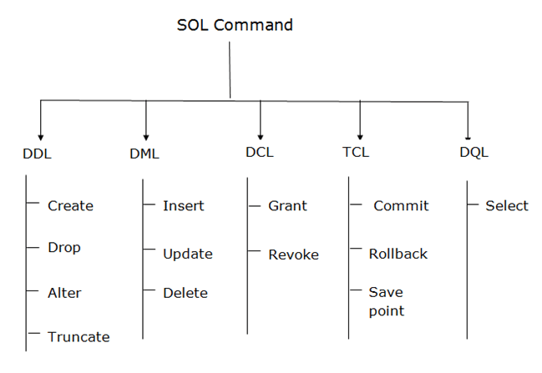

**DDL:**

DDL stands for Data Definition Language, which is a subset of SQL used to define the structure and schema of a database.

DDL commands include CREATE, ALTER, and DROP. For example, using DDL commands, you can create a new table in a database, modify an existing table's structure, or delete a table from the database.

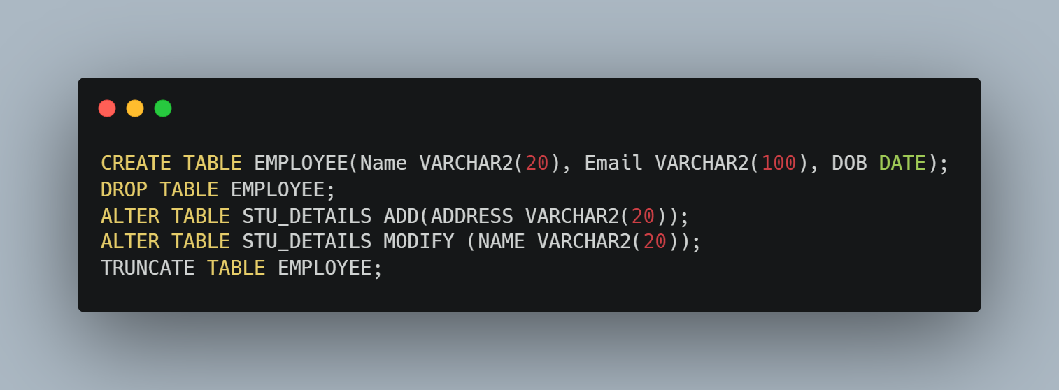

**DML:**

DML stands for Data Manipulation Language, which is a subset of SQL used to insert, update, and delete data in a database.

DML commands include SELECT, INSERT, UPDATE, and DELETE. For example, using DML commands, you can insert a new record into a table, update an existing record, or delete a record from the table.

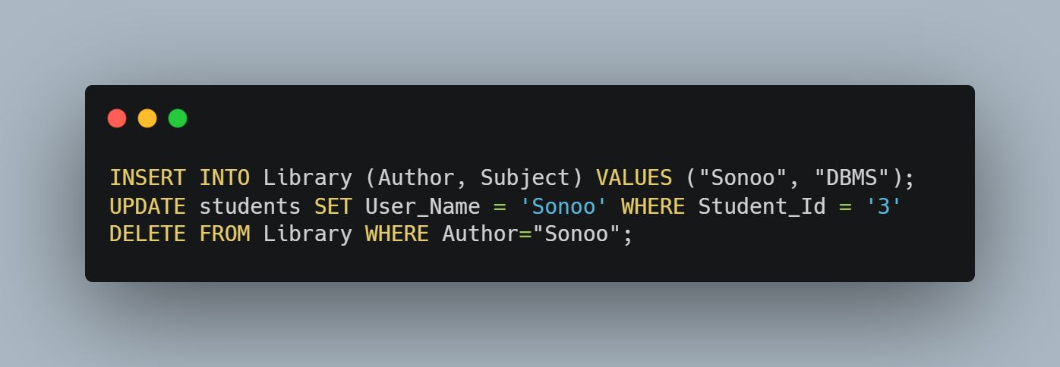

**TCL**:

TCL commands can only use with DML commands like INSERT, DELETE and UPDATE only.  
These operations are automatically committed in the database that's why they cannot be used while creating tables or dropping them.

Here are some commands that come under TCL: COMMIT, ROLLBACK, SAVEPOINT

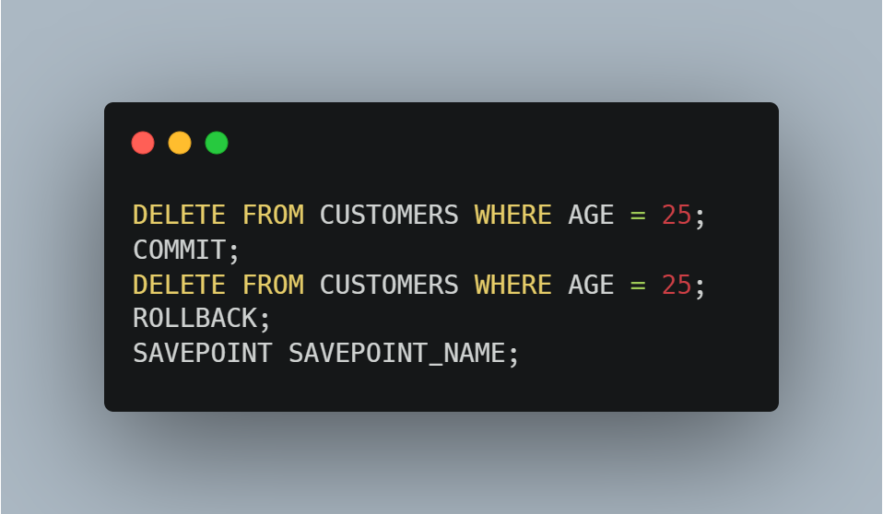

**DCL:**

DCL commands are used to grant and take back authority from any database user.

Here are some commands that come under DCL:

Grant: It is used to give user access privileges to a database.  
Revoke: It is used to take back permissions from the user.

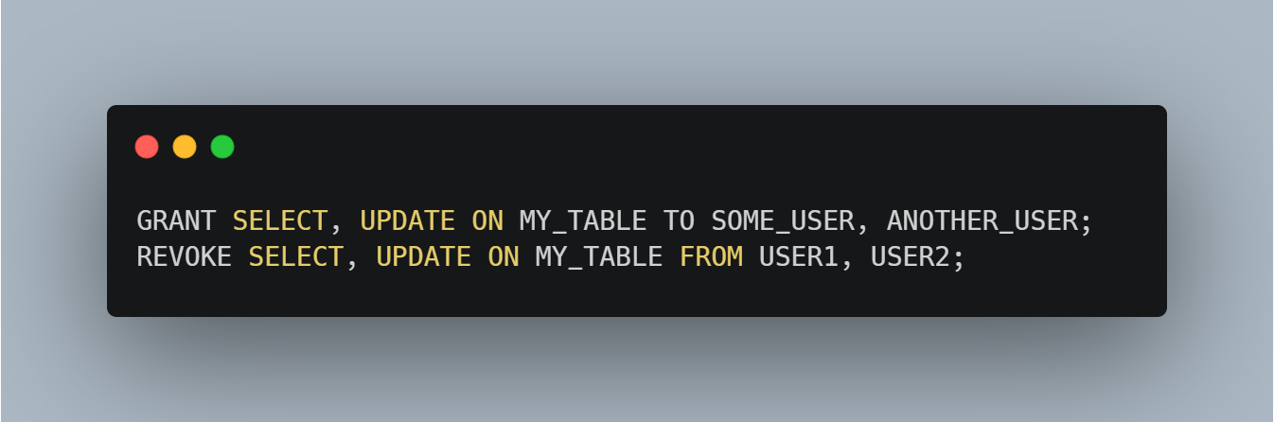

**DQL:**

DQL stands for Data Query Language, which is a subset of SQL used to retrieve data from a database.

DQL commands include SELECT. For example, using DQL commands, you can retrieve all the records from a table or retrieve only specific records that match certain criteria using WHERE clause.

